Queen’s House Conference 2017
European Court Culture & Greenwich Palace, 1500-1750

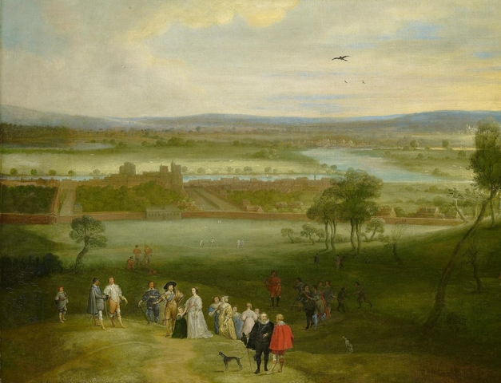
RCIN405291, Royal Collection Trust/© Her Majesty Queen Elizabeth II, 2017

Dates: 20-22 April 2017
Location: National Maritime Museum and the Queen’s House, Greenwich

Conference organisers: Janet Dickinson (University of Oxford), Christine Riding (Royal Museums Greenwich) and Jonathan Spangler (Manchester Metropolitan University). With support from the Society for Court Studies.

For queries about the programme, please contact Janet Dickinson: janet.dickinson@conted.ox.ac.uk For bookings, contact research@rmg.co.uk
Booking form: http://www.rmg.co.uk/see-do/exhibitions-events/queens-house-conference-2017

Thursday 20 April

12.30 – 13.00: Registration

13.00 – 15.00: Introduction, conference organisers

Jemma Field (Marie Skłodowska-Curie Fellow, Brunel University London), Greenwich Palace and Anna of Denmark: Royal Precedence, Royal Rituals, and Political Ambition
Karen Hearn (University College London), “‘The Queenes Picture therein’: Henrietta Maria amid architectural magnificence”
Anna Whitelock (Royal Holloway), Reconsidering the Political Role of Anna of Denmark

15.00 – 15.30: Refreshments

15.30 – 17.00
Christine Riding (Royal Museums Greenwich), Private Patronage, Public Display: The Armada Portraits and Tapestries, and Representations of Queenship
Natalie Mears (Durham University), Tapestries and paintings of the Spanish Armada: Culture and Horticulture in Elizabethan and Jacobean England
Charlotte Bolland (National Portrait Gallery), The Armada Portrait of Elizabeth I
17.00 – 18.00 Keynote lecture
Simon Thurley (Institute of Historical Research, London), Defining Tudor Greenwich: landscape, religion and industry

18.00 – 19.00 Wine reception in the Queen’s House. Followed by dinner at restaurant in Greenwich, at own expense.

Friday 21 April

9.30 – 11.00
Catriona Murray (University of Edinburgh), Raising Royal Bodies: Stuart Authority and the Monumental Image

Hannah Woodward (University of Glasgow), An Embroidered Truth? The Painted Brocades in Sixteenth-Century Portraits of Marie Of Guise

Jessica L. Malay (University of Huddersfield), Building the Palaces of the North: Anne Clifford’s Antiquarian Impulse

11.00 – 11.30 Refreshments

11.30 – 13.00
Maureen M. Meikle (Leeds Trinity University), “Queen Anna and her Architects: a tale of two Queen’s Houses”

Jane Spooner (Historic Royal Palaces), Framing Rubens: The Architectural Polychromy
of the Banqueting House Ceiling in Context
Anya Matthews (Old Royal Naval College), Queens, patronesses and goddesses: Royal women and the Painted Hall at Greenwich (1707-26)

13.00 – 14.30 Lunch and tours of the site. Scaffold tours of the ceiling at the Painted Hall are available during the conference, booking details below.

14.30 – 15.30
Wendy Hitchmough (Historic Royal Palaces), Anna of Denmark, Inigo Jones and the performance of monarchy

Gilly Lehmann, Henry VIII’s great feast at Greenwich in May 1527

15.30 – 16.00 Refreshments

16.00 – 17.00
Janet Dickinson (University of Oxford), The Tudors and the Tiltyard: Constructing royal authority at Greenwich

Sara Ayres (National Portrait Gallery), Paul van Somer's Portrait of Anne of Denmark in Hunting Costume (1617)

17.30 – 18.30 Keynote lecture
Susan Foister (National Gallery), Holbein and Greenwich

19.00: Dinner at own expense in restaurant in Greenwich

Saturday 22 April

9.30 – 11.00
Birgitte Dedenroth-Schou, The Danish /German influence on Anne of Denmark´s cultural interests

Fabian Persson (Linnaeus University), Protestant Prize? Princess Elizabeth, Marriage Negotiations and Dynastic Networking

Ineke Huysman (Huygens Institute), Epistolary Power. Anglo-Dutch Affairs in the Correspondence of the Dutch and Frisian Stadtholders' Wives (1605-1725)

11.00 – 11.30: Refreshments

11.30 – 12.30
Laura-Maria Popoviciu (Government Art Collection), ‘Great Britain’s New Solomon’? A Portrait of William III by Jan van Orley

David Taylor (National Trust), ‘Her Majesty’s Painter’: Jacob Huysmans and Catherine of Braganza

12.30 – 13.30: Lunch

13.30 – 15.00
Michele Frederick (University of Delaware), ‘Crossing the Sea’: Gerrit van Honthorst and Portraiture at the Stuart Courts

Julie Farguson (University of Oxford) ‘Glorious Successes at Sea’: The Artistic Patronage of Prince George of Denmark as Lord High Admiral, 1702-1708

J.D. Davies, Greenwich, the sovereignty of the seas and naval ideology in the Restoration

15.00 – 15.30: Refreshments

15.30 – 17.00
José Eloy Hortal Muñoz (Universidad Rey Juan Carlos, Madrid), The shape of the courtly space at the European Royal Sites of the seventeenth century: merging Court, Household and territory

Jacqueline Riding (Birkbeck College, University of London), A Stuart court at the Palace of Holyroodhouse in 1745

Barbara Arciszewska (University of Warsaw), Claiming Grunnewitsch: architecture of Inigo Jones and dynastic identity of the Hanoverians, c. 1700

17.00: Conference close.

The Painted Hall is offering scaffold tours during their conservation works, for a special view of the ceiling, at a cost of £10. These will be running throughout the lunch breaks for the conference and on Thursday morning. Bookings can be made directly with team in charge via this link: https://www.ornc.org/painted-hall-ceiling-tours

